Lab 4: Inserting Initial Data into the Database

Objective

To insert category and product records into the database using Entity Framework Core.

Commands Used
dotnet run

Program.cs
using RetailInventory.Data;
using RetailInventory.Models;
using var context = new AppDbContext();
var electronics = new Category
{
Name = "Electronics"
};
var groceries = new Category
{
Name = "Groceries"
};
context.Categories.Add(electronics);
context.Categories.Add(groceries);
context.SaveChanges();
var laptop = new Product
{
Name = "Laptop",
Price = 75000,
CategoryId = electronics.Id
};
var rice = new Product
{
Name = "Rice Bag",
Price = 1200,
CategoryId = groceries.Id
};
context.Products.Add(laptop);
context.Products.Add(rice);
context.SaveChanges();
Console.WriteLine("Data inserted successfully.");

Output
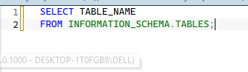
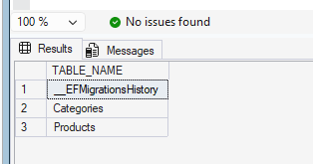
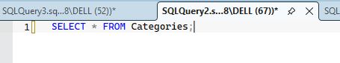
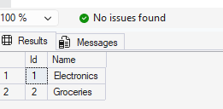
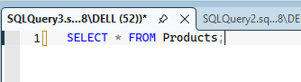
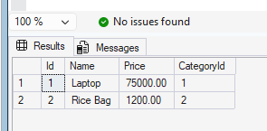

Result
The category and product records were inserted successfully into the RetailDB database using Entity Framework Core.

